DONE:

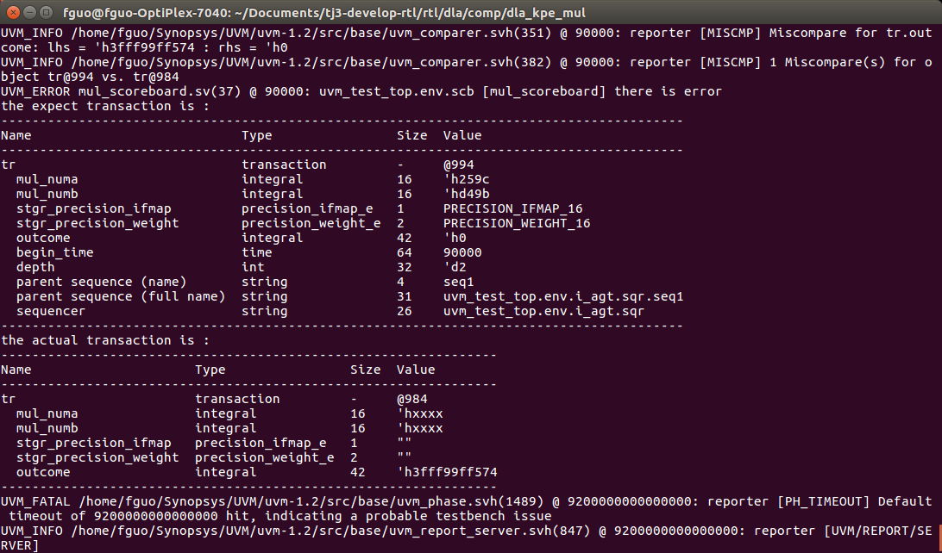1. Try to build the first testbench implemented in C and SystemVerilog for KPE multiplication. It still has several problems.

TO DO:

1.Continue the verification of component.